W-16
11 PHYSICS ATAR
ASSIGNMENT 6: WAVE MOTION

NAME: DUE DATE: TOTAL: 

1. Some examples of waves are sound, radio, microwaves, water waves and X-rays. Classify each of these waves under the correct heading.

Mechanical Waves | Electromagnetic Waves
(2)

2. Bridgette has seen a diagram of standing waves in a tube, and asks you what the curved lines
mean. Explain clearly what these lines represent.
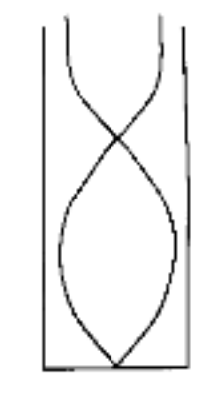

(3)

3. Brigette is watching some ducklings, which are paddling on a pond, when a wave approaches
them. Use arrows to show the direction of movement of each duckling at the instant shown on
the diagram. If there is no movement, label "no motion".
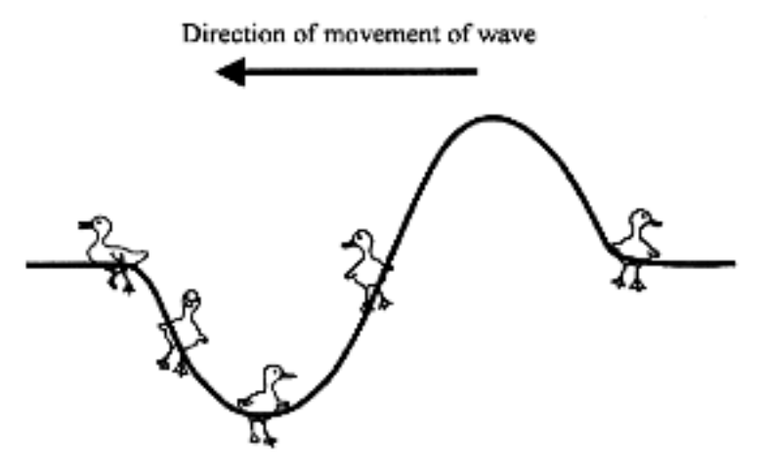
(2)
4. Draw the continuation of the periodic waveform shown up to 6 s.

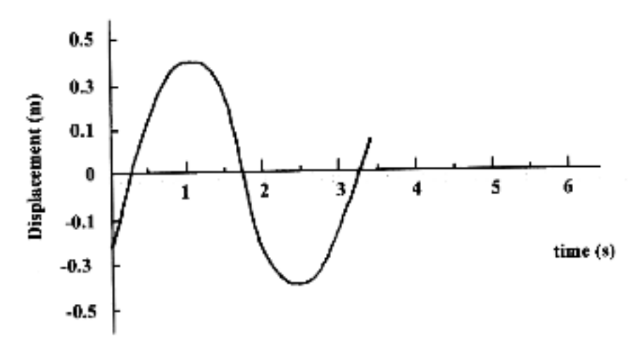
(4)

5. Twin-engined aircraft, such as those used by the Royal Flying Doctor Service, often produce a
sound that rises and falls in loudness.

(a) What is the name given to this effect?

(1)

(b) What are the conditions necessary for this effect to occur?

(2)

6. Two identical tuning forks vibrate at a frequency of 256 Hz. One of them has a drop of wax placed on
it. This lowers its frequency. When the two tuning forks are sounded, 6.0 beats per second are heard.
What is the frequency of the tuning fork with the wax on it? Show your working.

(3)

7. For the three properties of a sound wave (frequency, wavelength and speed), complete the table below,
stating whether the property is changed or unchanged when undergoing reflection, refraction and
diffraction. One property for diffraction has been completed for you.

Property | Reflection | Refraction | Diffraction
frequency |  |  | unchanged
wavelength
speed
(4)

8. The following oscilloscope trace shows the superposition of two waves. The horizontal axis is in
milliseconds.
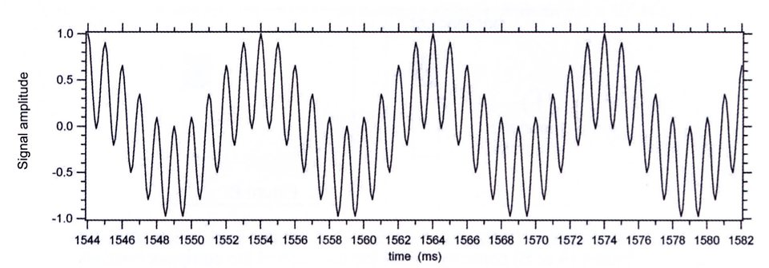
Calculate the frequency of each wave.

(4)

9. (a) Apart from the phenomenon of vibrating air columns, provide one example in which resonance
may be observed. Explain how resonance occurs in the example that you have chosen.

(3)

A loudspeaker emitting a single frequency is held over a tube that has one end placed in a cylinder
of water at 25.0 °C. As the length of tube in the water is changed, the sound heard also changes. The
equipment is illustrated in the diagram below.
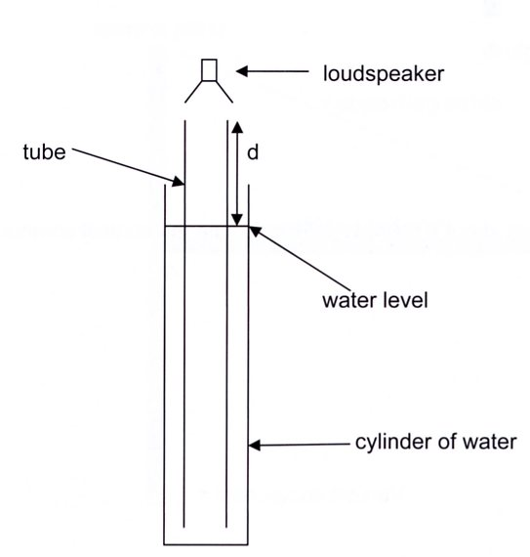

The first resonance is heard when the length of the air column above the water (labelled d in
the diagram) is 17.0 cm and a second is heard when the length of the air column is 49.0 cm.

(b) Calculate the wavelength of sound in the cylinder.

(2) (c) Calculate the frequency being emitted by the loudspeaker.

(2)

(d) The diagrams below show very simple versions of a flute and a clarinet.
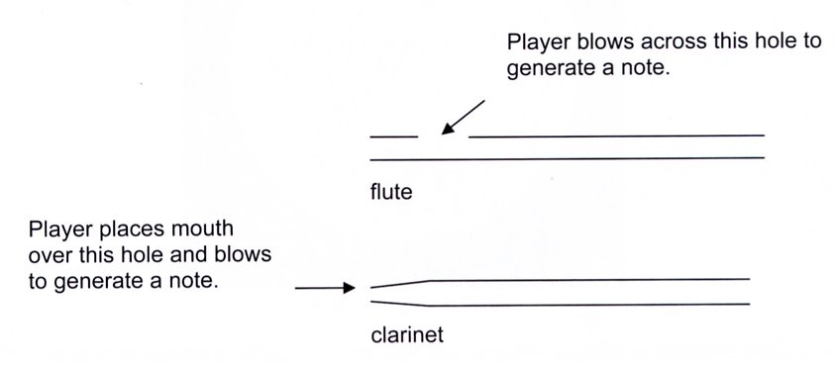

(i) The ratio of the first three frequencies heard in the flute f_{l}:f₂:f₃ is 1:2:3. Determine the
ratio of the first three frequencies heard in the clarinet.

(1)

(ii) Using your knowledge of vibrations in air columns, explain the differences between the
frequencies heard in the flute and those in the clarinet.

(3)
(e) Many instruments, such as the violin, work by setting up a standing wave in a string.

(i) How would you be able to tell there is a standing wave produced?

(1)

(ii) Explain how the standing wave is caused, describing the conditions necessary to
cause a standing wave.

(2)

(iii) With the aid of a diagram, explain a method you could use to measure the wavelength
of the standing wave.

(2)
10. Longitudinal sound waves propagated down a tube are reflected
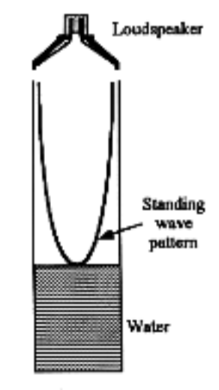
at the closed end and a standing wave is produced by the
interference of the incident and reflected waves.

The air is at rest at the closed end, which is therefore a node. The
antinode is actually a short distance e beyond the end of the tube,
thus l + e = /4 , where l is the length of the air column.

The speed of sound in the laboratory is given by v =f .

Hence

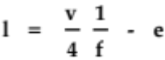

In an experiment to determine the speed of sound, a student uses
a tube in which the length of the air column can be adjusted by
varying the height of water in the tube.

A small loudspeaker is set up just above the tube. The length of the tube is set at a number of different values, and the sound frequency adjusted for resonance at each length.

The results obtained are given on the next page.

You are required to determine the speed of sound v in the laboratory and the distance e by drawing a straight- line graph.

(a) Explain how you will process the data to obtain a straight-line graph.

(2)
(b) Plot the straight-line graph for the following results. You may need to manipulate the data below.

l 140 190 250 300 350 400 450 (mm)
f 513 408 307 263 235 200 187 (Hz)

(5)

(c) From the straight-line graph determine:

(i) the speed of sound in the laboratory, v.

(4)

(ii) the distance e.

(3)



